2018 Fall CIS400 – Assignment 1

Instructor: Dr. Jie Shen
Release date: Sep 19, 2018
Due date: Oct09, 2018

Question 1
Compute the weakest precondition for each of the following sequences of assignment statements and their postconditions:
- a := 2.0 * b + 2;
b := a * 2 + 2;
{b<0}
- a := 2 * (2 * b + 1);
b := 2 * a + 1
{b > 5}

Question 2
Given a grammar:

<assign> → <id> = <expr>
<id> → A | B | C
<expr> → <id> + <expr>
| <id> * <expr>
| ( <expr> )
| <id>

Show two different parse trees can be generated on the following statement:

A = A + B * C

Is the grammar ambiguous ? If yes, how can you fix it ? Show the parse tree

after the fix.

Question 3
Consider the following program:

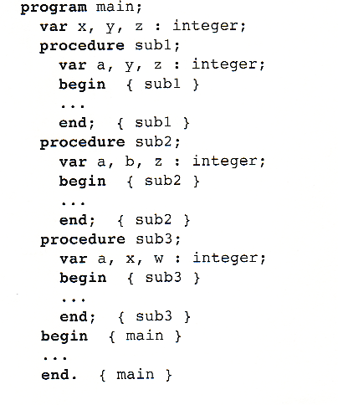
Given the following calling sequences and assuming that dynamic scoping is used, what variables are visible during execution of the last subprogram activated? Include with each visible variable the name of the unit where it is declared.
a. main calls sub1; sub1 calls sub2; sub2 calls sub3.

Question 4. Do an Internet research and write a one-page summary about Flex and Bison, respectively.

Question 5. Consider the following EBNF grammar for a “Calculator Language”:

< calculation> → <expression> =
<expression> → <term> [ (- | /) <expression> ]
<term> → <value> [ (+ | *) <term> ]
<value> → [ <sign> ] <unsigned> [ . <unsigned> ]
<unsigned> → <digit> { <digit> }
<digit> → 0 | 1 | 2 | 3 | 4 | 5 | 6 | 7 | 8 | 9
<sign> → + | -

which of the following sentences are in the language generated by this grammar ?

- 3 * + - 2.5 =
- 5 / - 3 * 4 =
- (3 * 2 ) + 3 =
- 5 *+3 =
- 3-2++4=

Question 6
Write a pseudo-interpreter of the “Calculator Language” defined in Question 5 in C or C++ language. The evaluation of the user-input expression begins once a “=” character is read. Until then, the characters are buffered in a user_input string variable. The only characters that are accepted are the terminals of the calculator language: (0 1 2 3 4 5 6 7 8 9 + - * / . =).

The interpreter can be implemented by a while loop and terminates when a character ‘x’ is read. Your interpreter is required not only to identify if an input string belongs to the language defined by the grammar in Q5, but also to evaluate the input string and print out the evaluation result on computer screen.

The interpreter works by using the EBNF grammar recursively to resolve the input string into its component parts. There should be a single procedure for each non-terminal in the grammar. In the case of a successful parsing, your code should print out the evaluation result of an input expression. In the event of a failed parsing, an error message is output to the screen.

You should try the following test cases and report the result of each case:
- 3 + 5 / 2 =
- 5 – +3 + 2 =
- 5 *+3 – 2 =
- 0.4 - / 2.0 * 3.0 =
- (3 + 5) / 2 =

Further Explanation
- I/O
- You should provide Screen output
- Test Cases
- Illegal expression
- Integer expression w/o unary (+/-)
- Float type expression w/o unary (+/-)
- No operator precedence. The evaluation result may contradict with mathematical calculation.
- While-loop evaluation with ‘x’ to terminate
- Source code and a simple documentation.
- Scan the input string from left to right and use leftmost derivation
- Each recursion function will return the result of a part of expression. At the top level, you need to print out the result of the input expression after being evaluated.
- You may use the following routines to convert a string to an integer or a float type variable:
#include <math.h>
#include <stdlib.h>
int i = atoi(“-1”); float r = atof(“-1.3”);

